|  |  |  |  |  |  |
| --- | --- | --- | --- | --- | --- |
|  | Consumer Confidence Report 2021  **This is the annual report of your drinking water to help you be better informed and is also required to be distributed annually by federal Safe Drinking Water Act (SDWA) and the State of Washington.** | | |  | |
| **Water Use Efficiency**  All water districts are required to set measurable water efficiency goals. This means the difference between metered water from source and metered water billed. Belfair Water District had a loss for 2021 of 11.2%. The State of Washington set goals for all districts to be below 10%. As of the end of 2021 we have changed out 2/3 or the districts consumer meters and all of our source meters. We have been prompt on leak repairs, plus we have scheduled for 2022 with a leak detection company  **Your Drinking Water Supply**  Belfair Water District has four ground water wells, three wells on the south end of the district, one well on the north end. These wells provide water from deep aquifers (ground water) minimally treated with chlorine, then pumped to five reservoirs around the district and tested as required by Washington Department of Health and U.S EPA  1-800-426-4791. | | | | |
| News | | | | |
| **We cleaned the interior and exterior of our storage tanks at 39 Acres and Rasor Road sites and installed new vent’s. We also repaired the road and drain at our 39 Acres site.**  **We rehabilitated Well #1 building. A new fire hydrant was installed on Log Yard RD. Five water main breaks were repaired.**  **Our shop on HWY 3 was burglarized so in response our field experts replaced equipment and installed new security measures.** | | **We worked closely with new Fire Station on Old Belfair Hwy during their new water main installation. During the Old Belfair HWY widening project we raised all the valve cans and meter boxes along the roadway and replaced several of the older water meters for existing customers.**  **No violations were reported for 2021.**  **We continue to be committed to the highest quality of drinking water and to be in good standing with the community and state of Washington.** | Meet our staff  Greg Born, Chairman  Jill Satran-Loudin, Treasurer Mike Pope, Secretary  **General Manager:**  Dale Webb, 21 years’ experience in the waterworks industry  **Field Technician:**  James Freeman, 22 years hands-on in the waterworks industry  **Office Manager:**  Lisa Douglas  **Customer Service:**  Meryl Flynn  **Public Participation**  Water District customers are invited to attend regular Commissioner District meetings.  When: 2nd and 4th Tuesdays of the month  Time: 5:00pm  Where: 22451 Highway 3 Belfair, WA 98528  For more information contact Dale Webb- General Manager  www.belfairwater.org | |
| nature-water-drops-of-water-liquid-40784 | | |

|  |  |  |  |  |  |  |
| --- | --- | --- | --- | --- | --- | --- |
| **Contaminant/Units** | **MCLG** | **MCL** | **Result** | **Sample Date** | **Violation** | **Typical Source** |
| Disinfection By-Products Total Trihalomethane (ppb) | 0 | 80 | ND | 8-04-2021 | NO | By product of drinking water by disinfection |
| Halo- Acetic Acids | 0 | 60 | ND | 08-04-2021 | NO | By product of drinking water by disinfection |
| **Inorganic Chemicals** |  |  |  |  |  |  |
| Nitrate | 10 | 10 | <0.20 | 09-28-2021 | NO | Runoff from fertilizer use; Leaching from septic tanks, sewage Erosion of natural deposits |
| **Volatile Organic Compounds** |  |  |  |  |  |  |
| Herbicides |  |  |  | 06-25-2021 | NO |  |
| Lead | 0 | .15AL | .001 | 07-28-2020 | NO | Plumbing Materials |
| Gross Alpha |  |  | ND | 09-16-2021 | NO |  |
| Radium |  |  | ND | 09-16-2021 | NO |  |
| Copper | 1.3 | 1.3 | ND | 07-28-2020 | NO | Plumbing |



**2021 Water Quality Data Table**

The Environmental Protection Agency regulates the frequency of sampling for various contaminates. The data presented in this table is from testing conducted in 2021

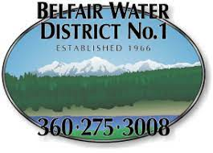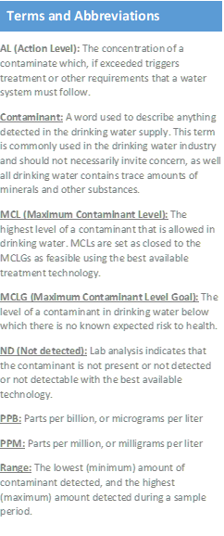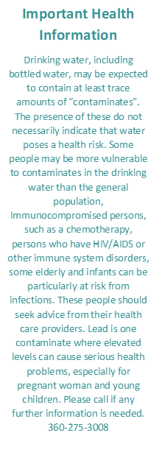

Coliform Sampling

**Belfair Water District #1 is required to take three total coliform bacteria samples a month. Although TC bacteria by itself are in fact common in the environment, the presence of TC bacteria indicates that more testing is required**

